ER Diagram

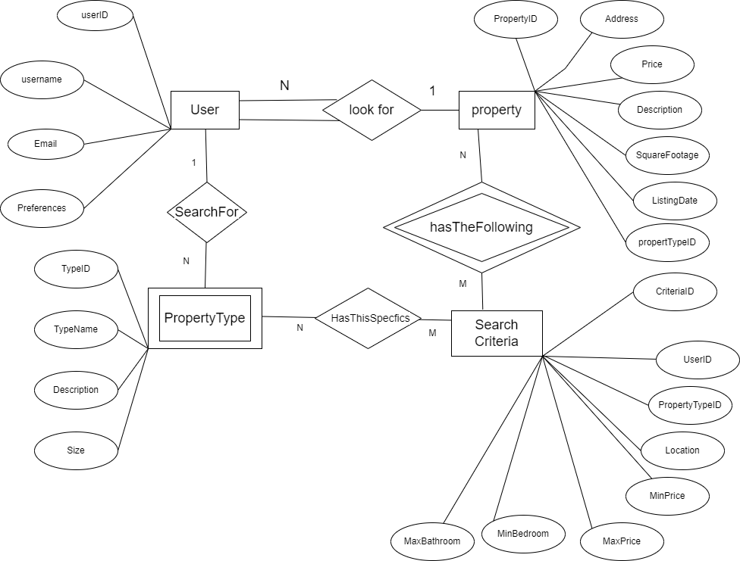

Relationships:

\* A user can have many properties (one-to-many)

\* A property can belong to one property type (one-to-many)

\* A property can have many search criteria (one-to-many)

\* A search criteria can be used by many properties (many-to-many)

Primary Keys:

Primary Key: UserId

Primary Key: TypeId

Primary Key: PropertyId

Primary Key: CriteriaId

Foreign Keys:

Foreign Key: TypeId

References: PropertyType(TypeId)

Foreign Key: UserId

References: User(UserId)